**Kubernetes**

**Content:**

what is Kubernetes

k* Architecture

Main K*s Components

MiniKube and Kubectl -local setup

Main Kubectl Commands -K8s CLI

K8s YAML Configuration File

K8s Namespaces -Organize your Components

K8s Ingress

Helm -package Manager

Volumes – persisting Data in K8s

K8s Stateflset – Deploying Stateful Apps.

K8s Services

**Basics of Kubernetes:**

**Pod:**

**Pod is abstraction over container.**

It is the smallest and simplest basic unit of the Kubernetes application. This object indicates the processes which are running in the cluster.

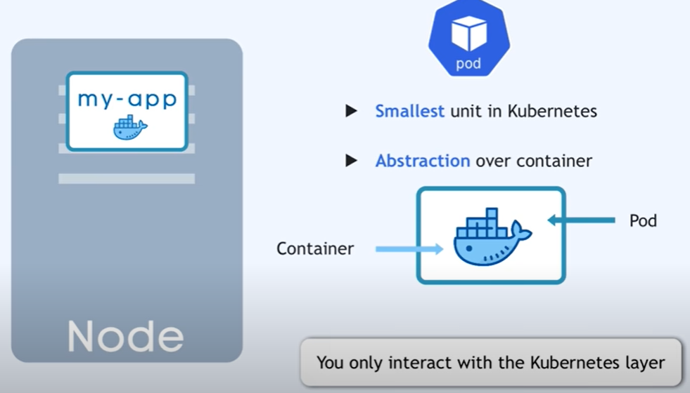

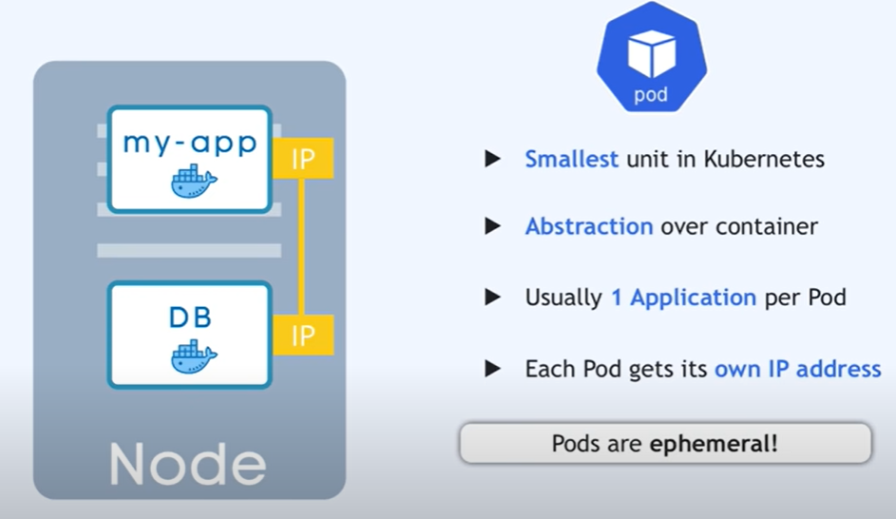

**Node**

A **node** is nothing but a single host, which is used to run the **virtual or physical machines**. A node in the Kubernetes cluster is also known as a minion.

**OR**

### **Node:**

It is a single host which is capable of running on a physical or [virtual machine](https://www.guru99.com/best-virtual-machine-software.html). A node should **run both kube-proxy, minikube, and kubelet which are considered as a part of the cluster**.

### **Cluster**:

It is a collection of hosts(servers) that helps you to aggregate their available resources. That includes ram, CPU, ram, disk, and their devices into a usable pool.

### **Master**:

The master is a collection of components which make up the control panel of Kubernetes. These components are used for all cluster decisions. It includes both scheduling and responding to cluster events.

**Service**

A **service** in a Kubernetes is a logical set of pods, which works together. With the help of services, users can easily manage load balancing configurations.

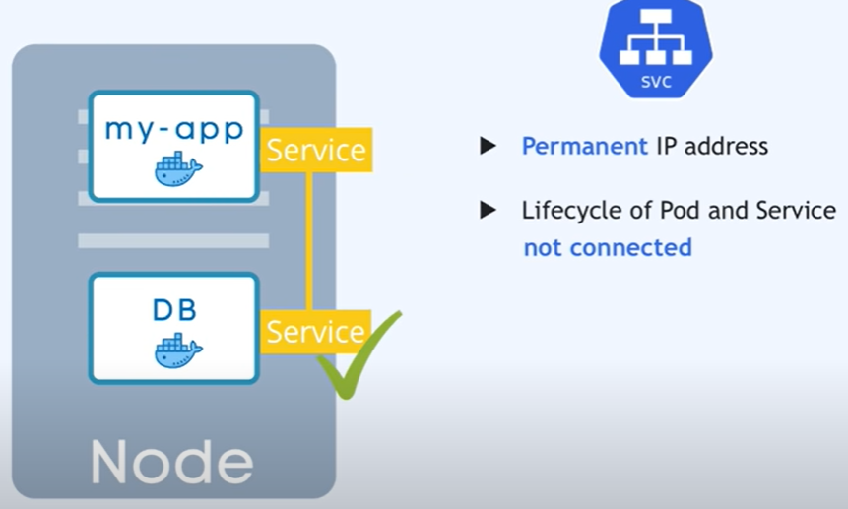

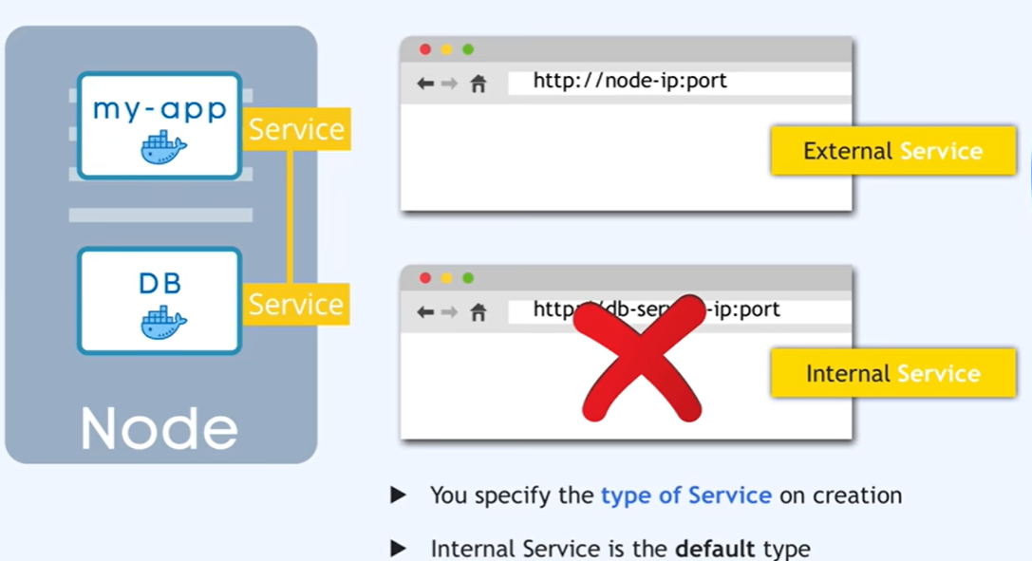

**ReplicaSet**

A **ReplicaSet** in the Kubernetes is used to identify the particular number of pod replicas are running at a given time. It replaces the replication controller because it is more powerful and allows a user to use the "set-based" label selector.

**Namespace**

Namespace provides an additional qualification to a resource name. This is helpful when multiple teams are using the same cluster and there is a potential of name collision. It can be as a virtual wall between multiple clusters.

**ConfigMap**:

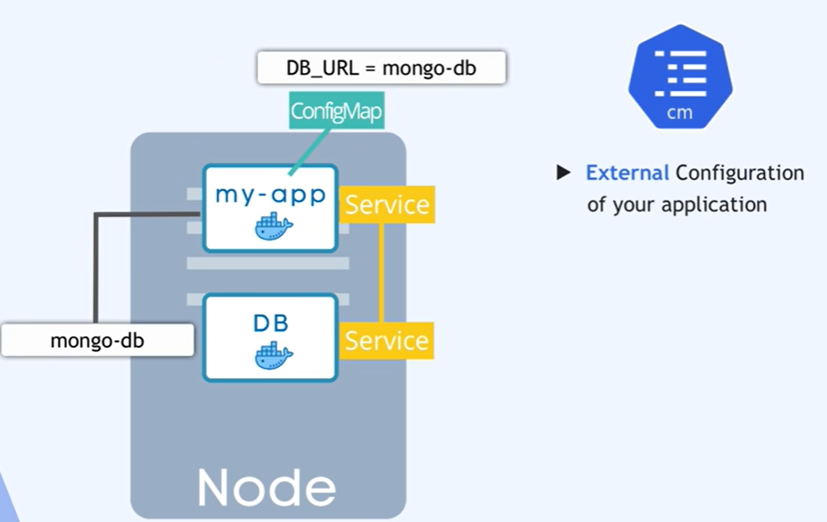

**Secret:**

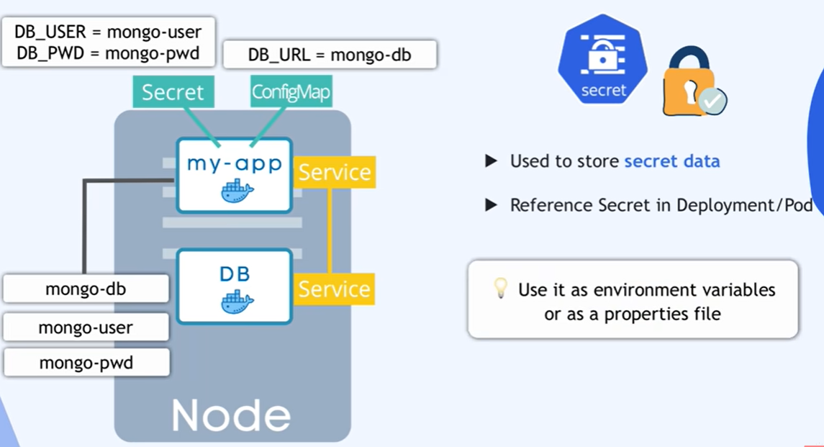

**Volume:**

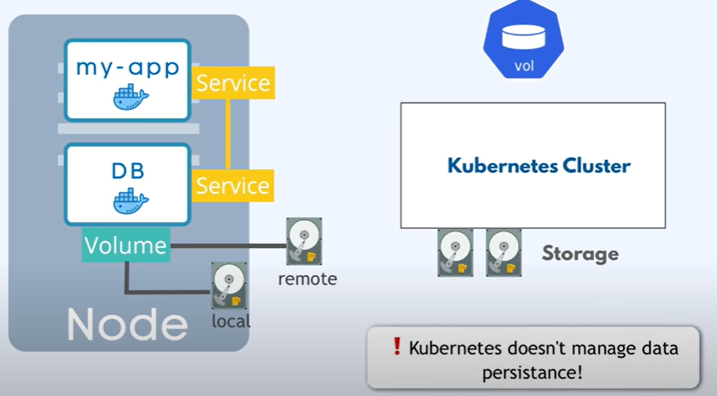

**Ingress:**

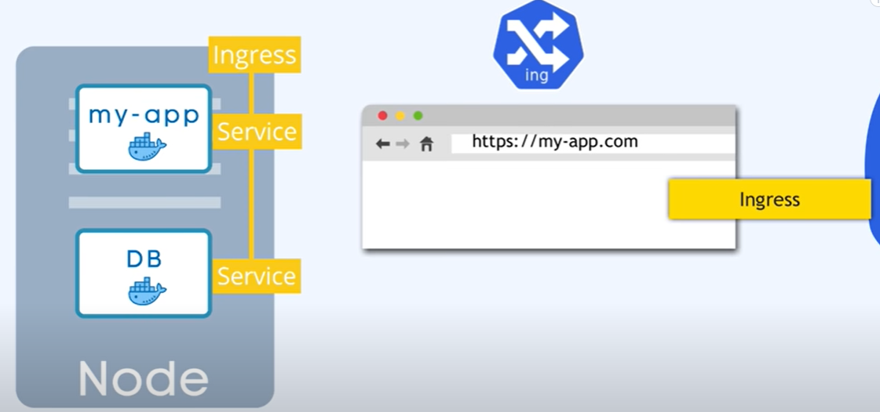

### **Replication Controllers**

A replication controller is an object which defines a pod template. It also controls parameters to scale identical replicas of Pod horizontally by increasing or decreasing the number of running copies.

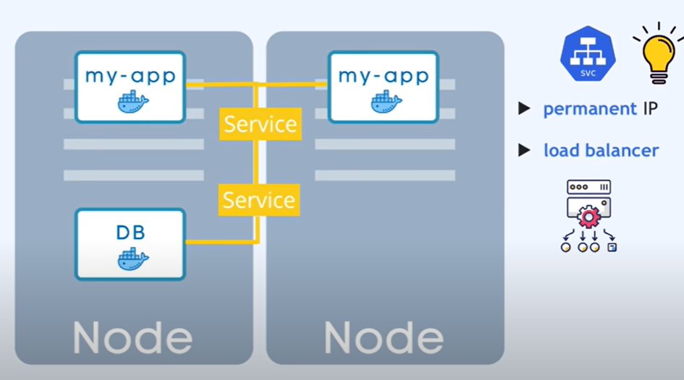

### **Replication Sets**

Replication sets are an interaction on the replication controller design with flexibility in how the controller recognizes the pods it is meant to manage. It replaces replication controllers because of their higher replicate selection capability.

### **Deployments**

Deployment is a common workload which can be directly created and manage. Deployment use replication set as a building block which adds the feature of life cycle management.

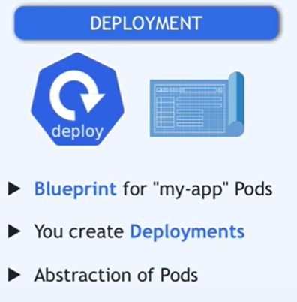

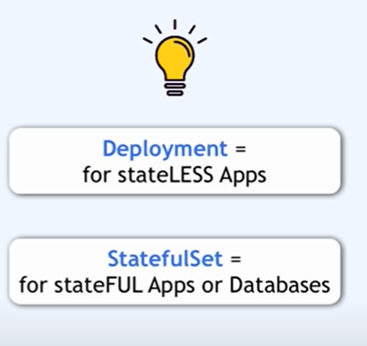

### **Stateful Sets**

It is a specialized pod control which offers ordering and uniqueness. It is mainly used to have fine-grained control, which you have a particular need regarding deployment order, stable networking, and persistent data.

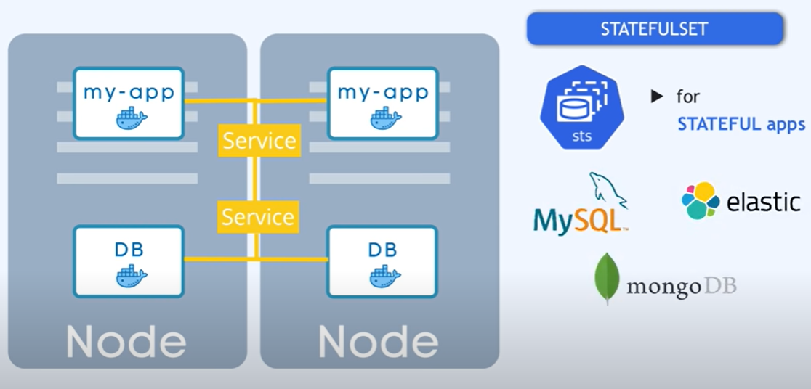

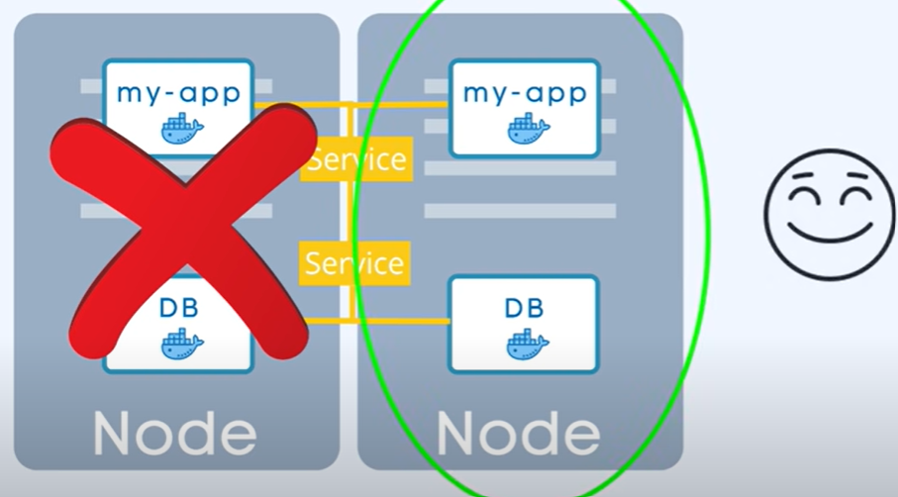

### **Daemon Sets**

Daemon sets are another specialized form of pod controller that runs a copy of a pod on every node in the cluster. This type of pod controller is an effective method for deploying pods that allows you to perform maintenance and offers services for the nodes themselves.

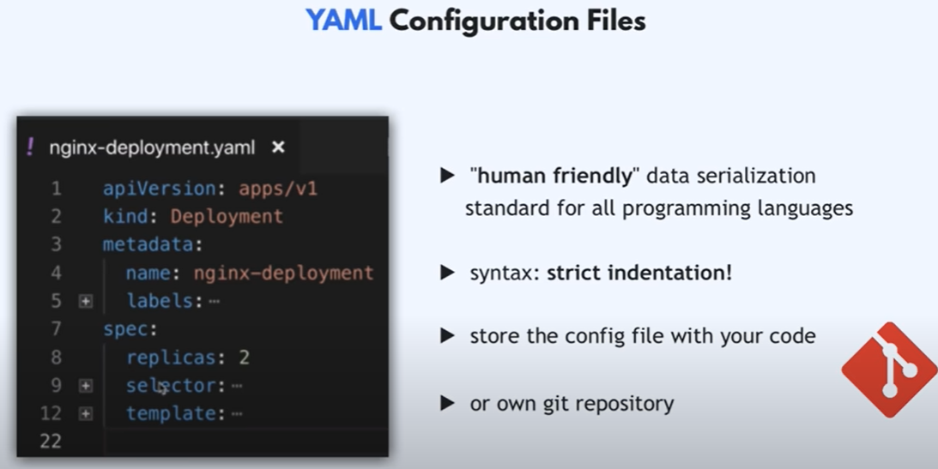

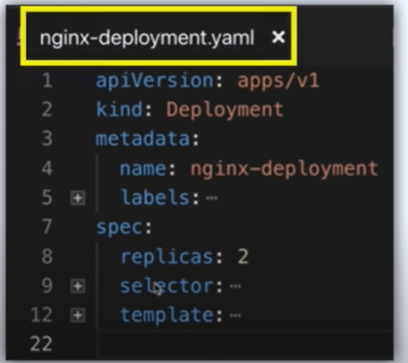

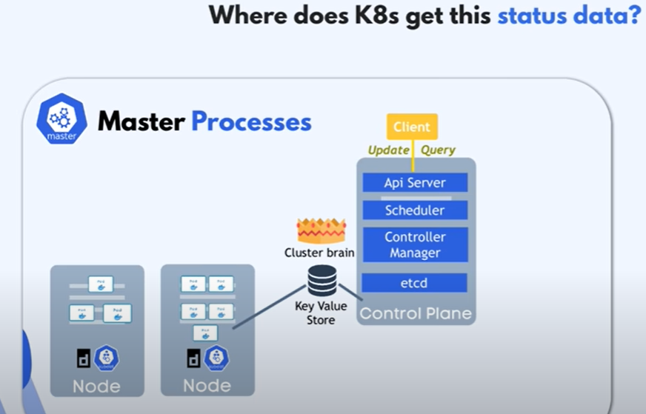

Etcd holds the current status of any k8 s components.

Features of Kubernetes

Following are the essential features of Kubernetes:



1. **Pod:** It is a deployment unit in Kubernetes with a single Internet protocol address.
2. **Horizontal Scaling:** It is an important feature in the Kubernetes. This feature uses a **HorizontalPodAutoscalar** to automatically increase or decrease the number of pods in a deployment, replication controller, replica set, or stateful set on the basis of observed CPU utilization.
3. **Automatic Bin Packing:** Kubernetes helps the user to declare the maximum and minimum resources of computers for their containers.
4. **Service Discovery and load balancing:** Kubernetes assigns the IP addresses and a Name of DNS for a set of containers, and also balances the load across them.
5. **Automated rollouts and rollbacks:** Using the rollouts, Kubernetes distributes the changes and updates to an application or its configuration. If any problem occurs in the system, then this technique rollbacks those changes for you immediately.
6. **Persistent Storage:** Kubernetes provides an essential feature called '**persistent storage'** for storing the data, which cannot be lost after the pod is killed or rescheduled. Kubernetes supports various storage systems for storing the data, such as **Google Compute Engine's Persistent Disks (GCE PD) or Amazon Elastic Block Storage (EBS).** It also provides the distributed file systems: **NFS or GFS**.
7. **Self-Healing:** This feature plays an important role in the concept of Kubernetes. Those containers which are failed during the execution process, Kubernetes restarts them automatically. And, those containers which do not reply to the user-defined health check, it stops them from working automatically.

## Kubernetes Architecture

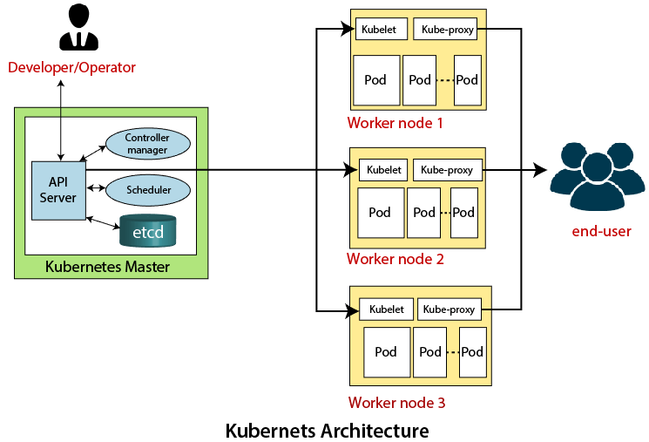

**OR**

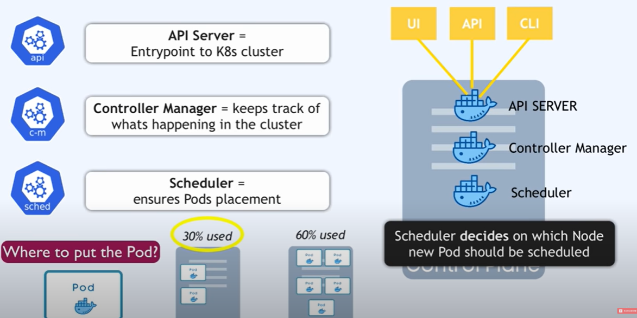

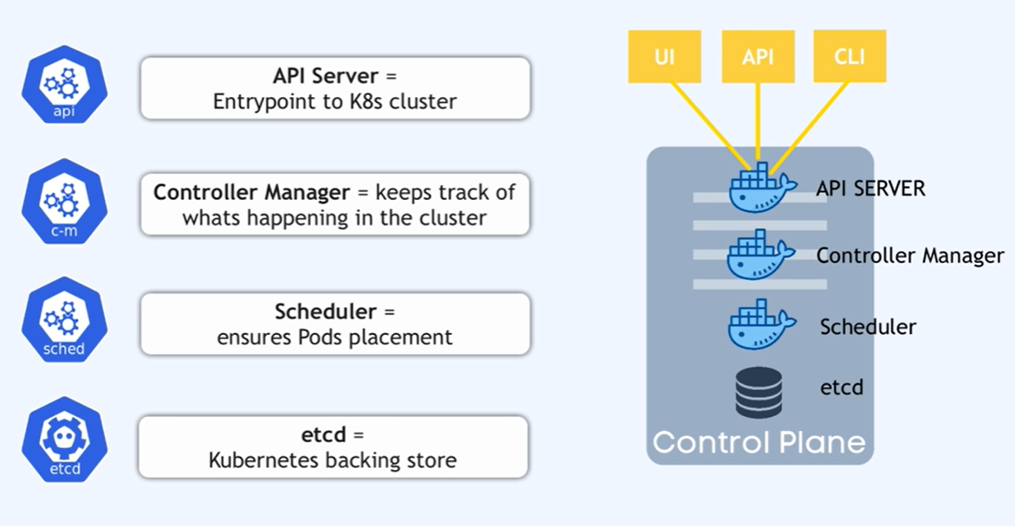

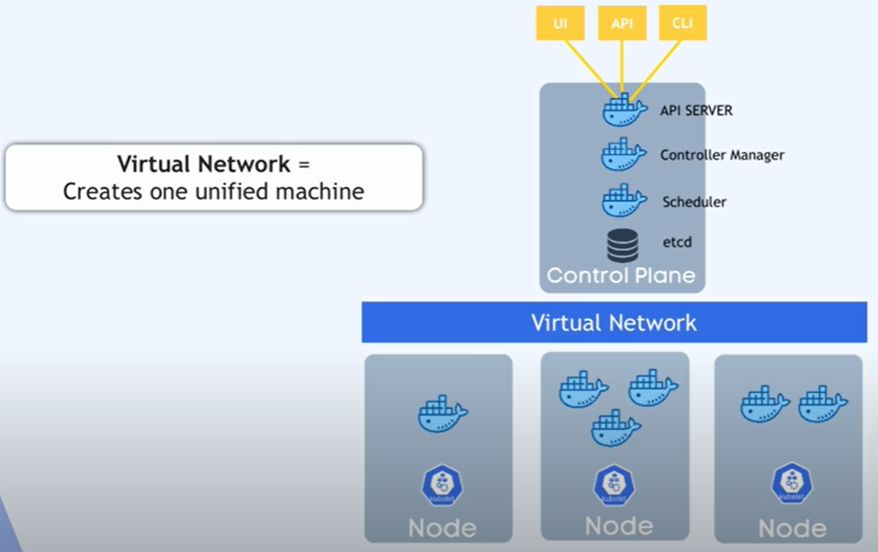

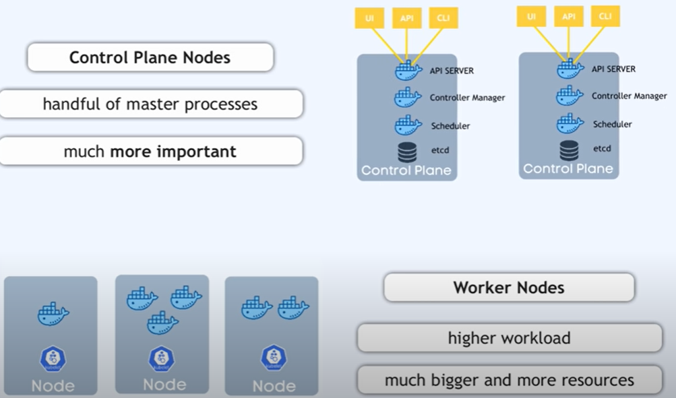

The architecture of Kubernetes actually follows the client-server architecture. It consists of the following two main components:

1. Master Node (Control Plane)
2. Slave/worker node

### **Master Node or Kubernetes Control Plane**

The master node in a Kubernetes architecture is used to manage the states of a cluster. It is actually an entry point for all types of administrative tasks. In the Kubernetes cluster, more than one master node is present for checking the fault tolerance.

Following are the four different components which exist in the Master node or Kubernetes Control plane:

1. API Server
2. Scheduler
3. Controller Manager
4. ETCD

**API Server**

The Kubernetes API server receives the REST commands which are sent by the user. After receiving, it validates the REST requests, process, and then executes them. After the execution of REST commands, the resulting state of a cluster is saved in '**etcd**' as a distributed key-value store.

**Scheduler**

The scheduler in a master node schedules the tasks to the worker nodes. And, for every worker node, it is used to store the resource usage information.  
In other words, it is a process that is responsible for assigning pods to the available worker nodes.

**Controller Manager**

The Controller manager is also known as a controller. It is a daemon that executes in the non-terminating control loops. The controllers in a master node perform a task and manage the state of the cluster. In the Kubernetes, the controller manager executes the various types of controllers for handling the nodes, endpoints, etc.

**ETCD**

It is an open-source, simple, distributed key-value storage which is used to store the cluster data. It is a part of a master node which is written in a GO programming language.

Now, we have learned about the functioning and components of a master node; let's see what is the function of a slave/worker node and what are its components.

### **Worker/Slave node**

The Worker node in a Kubernetes is also known as minions. A worker node is a physical machine that executes the applications using pods. It contains all the essential services which allow a user to assign the resources to the scheduled containers.

Following are the different components which are presents in the Worker or slave node:

**Kubelet**

This component is an agent service that executes on each worker node in a cluster. It ensures that the pods and their containers are running smoothly. Every **kubelet** in each worker node communicates with the master node. It also starts, stops, and maintains the containers which are organized into pods directly by the master node.

**Kube-proxy**

It is a proxy service of Kubernetes, which is executed simply on each worker node in the cluster. The main aim of this component is request forwarding. Each node interacts with the Kubernetes services through **Kube-proxy**.

**Pods**

A **pod** is a combination of one or more containers which logically execute together on nodes. One worker node can easily execute multiple pods.

**MiniKube and Kubectl - local setup:**

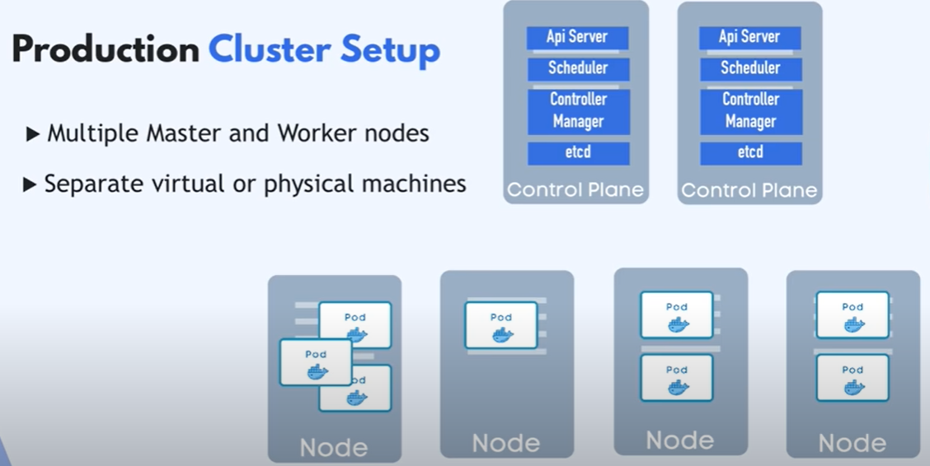

**MiniKube:**

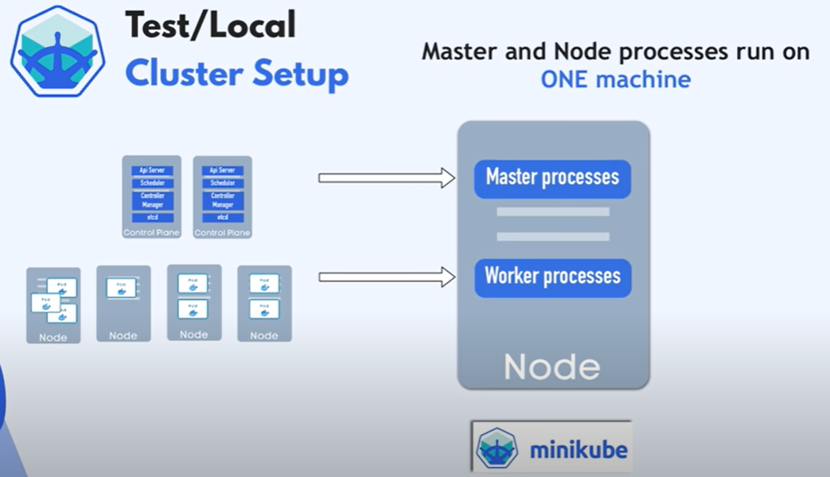

**It will has docker container pre install in miniKube.**

**Kubectl:**

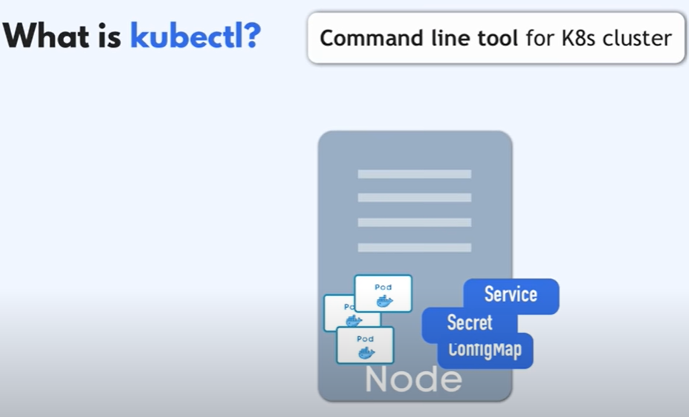

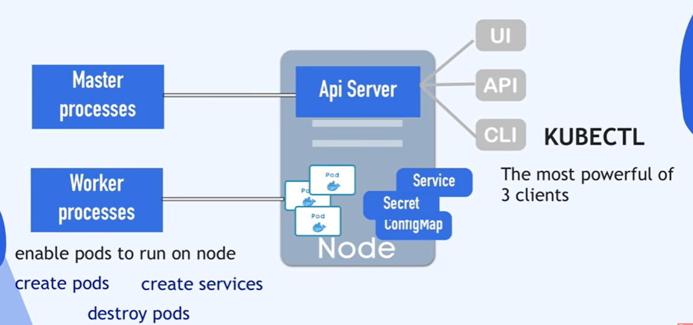

**DEMO** :

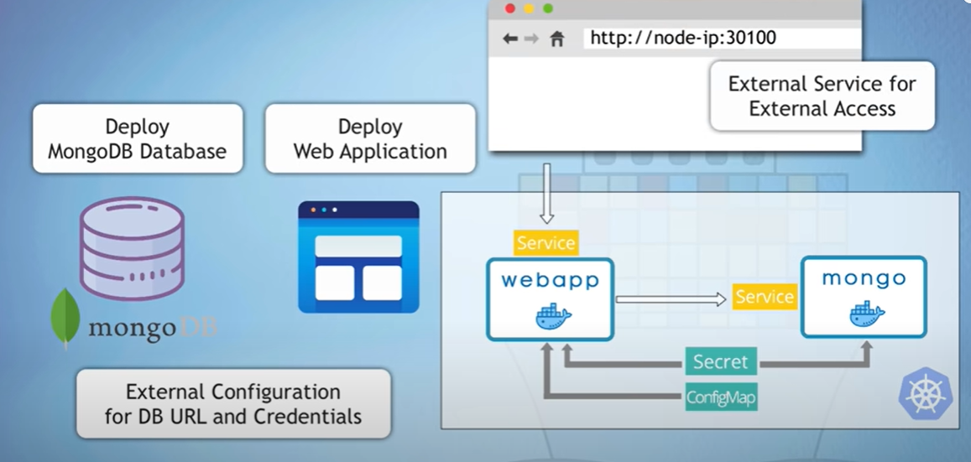

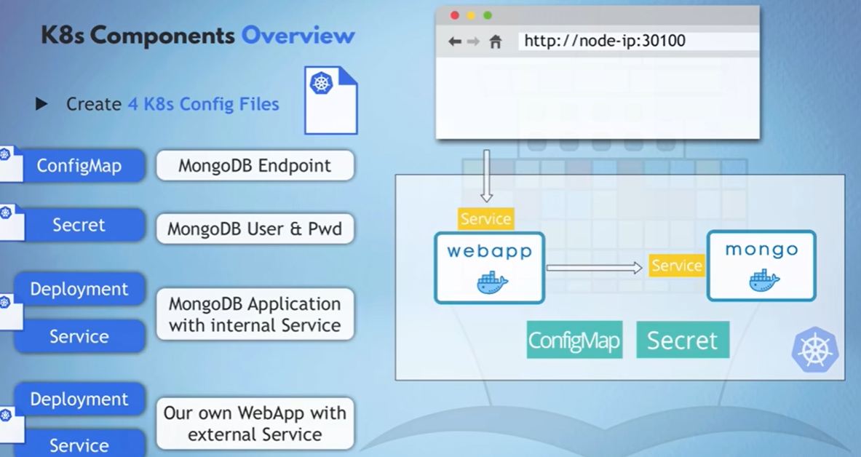

**Mongo-config: File.**

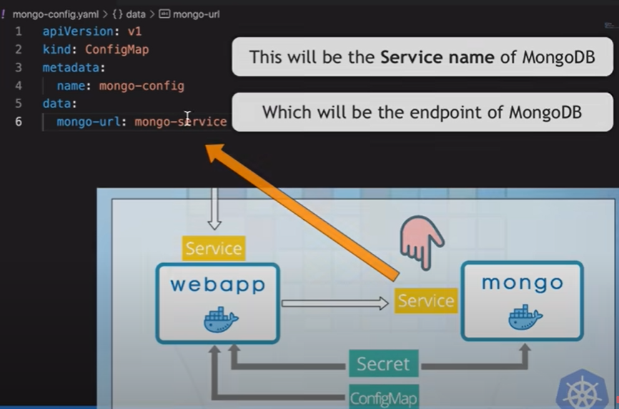

**Mongo-secret: File**

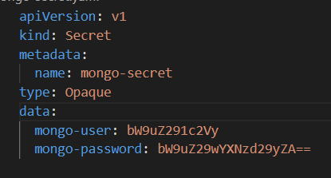

**Mongo.yaml: File**

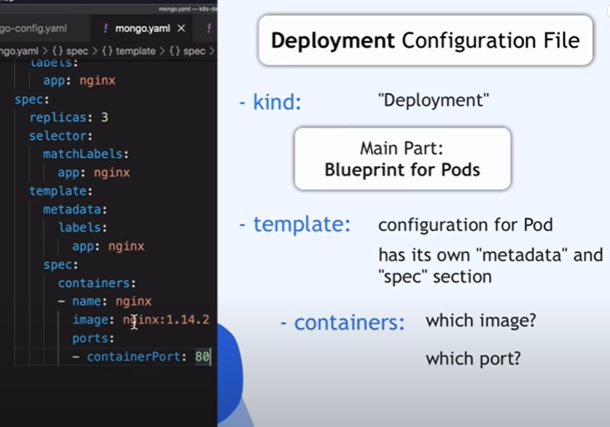

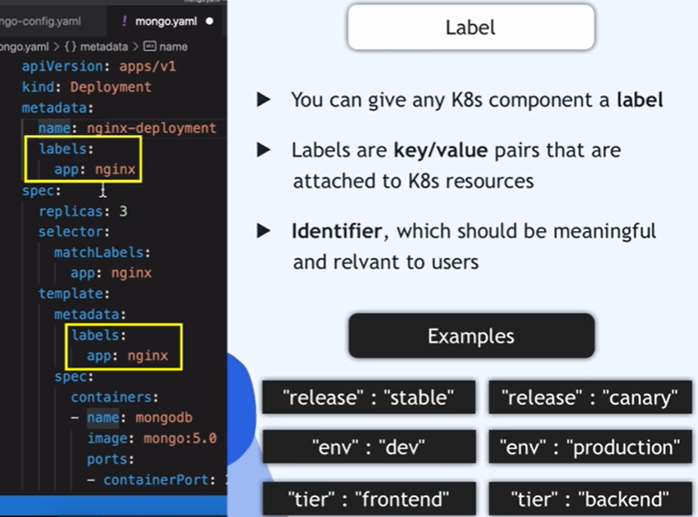

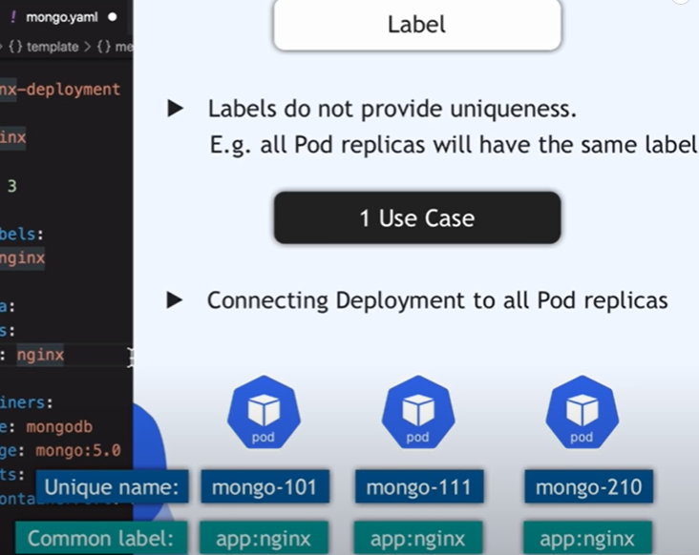

**Commands**:

Pause Kubernetes without impacting deployed applications:

minikube pause

Unpause a paused instance:

minikube unpause

Halt the cluster:

minikube stop

Change the default memory limit (requires a restart):

minikube config set memory 9001

Browse the catalog of easily installed Kubernetes services:

minikube addons list

Create a second cluster running an older Kubernetes release:

minikube start -p aged --kubernetes-version=v1.16.1

Delete all of the minikube clusters:

minikube delete --all

**All command for reference:**

minikube provisions and manages local Kubernetes clusters optimized for development workflows.

Basic Commands:

start Starts a local Kubernetes cluster

status Gets the status of a local Kubernetes cluster

stop Stops a running local Kubernetes cluster

delete Deletes a local Kubernetes cluster

dashboard Access the Kubernetes dashboard running within the minikube cluster

pause pause Kubernetes

unpause unpause Kubernetes

Images Commands:

docker-env Provides instructions to point your terminal's docker-cli to the Docker Engine inside minikube.

(Useful for building docker images directly inside minikube)

podman-env Configure environment to use minikube's Podman service

cache Manage cache for images

image Manage images

Configuration and Management Commands:

addons Enable or disable a minikube addon

config Modify persistent configuration values

profile Get or list the current profiles (clusters)

update-context Update kubeconfig in case of an IP or port change

Networking and Connectivity Commands:

service Returns a URL to connect to a service

tunnel Connect to LoadBalancer services

Advanced Commands:

mount Mounts the specified directory into minikube

ssh Log into the minikube environment (for debugging)

kubectl Run a kubectl binary matching the cluster version

node Add, remove, or list additional nodes

cp Copy the specified file into minikube

Troubleshooting Commands:

ssh-key Retrieve the ssh identity key path of the specified node

ssh-host Retrieve the ssh host key of the specified node

ip Retrieves the IP address of the specified node

logs Returns logs to debug a local Kubernetes cluster

update-check Print current and latest version number

version Print the version of minikube

options Show a list of global command-line options (applies to all commands).

license Outputs the licenses of dependencies to a directory

Other Commands:

completion Generate command completion for a shell